The Welsh Government, and the Learning and Work Institute, want to create Wales’ largest-ever bank of digital adult learning resources and we want you to be a part of it.

Adult Learners' Week
change your story, online
COVID-19 has had a huge impact on all aspects of life for everyone across Wales.
The economic market is facing uncertain times with businesses temporarily closed, employees being furloughed or potential redundancies on the horizon.
As well as the above, many people feel isolated, lonely and are struggling with their health and wellbeing.
That’s why now more than ever, we need to pool our resources and work together to support Wales through a new Adult Learners' Week online learning platform.
The platform will give people access to free and paid for courses – where they can learn new skills, take their careers to the next level or simply explore new interests. This will be complemented by a multichannel
marketing campaign that raises awareness of the resource and encourages Wales to keep learning.
To make this a success, we need the best partners – training, educational, skills-based, and community learning experts - to contribute to the courses, tutorials, and webinars, sharing access to new or existing materials.
We need a high volume of quality online tutorials and courses in Welsh and English.
We’d like a variety of options to inspire and support adult learning, helping with health and wellbeing, such as flower arranging or creative writing or more practical skills which may lead
to further qualifications, such as basic maths or advanced social media marketing.
We already have Open University in Wales, National Museum Wales and Swansea Lifelong Learning Service signed up as partners and we would like to invite you to join our mission.
Partner benefits
- An opportunity to engage with new and existing audiences
- Support creating or adding to a bank of online learning activities
- Playing your part in helping people in Wales tackle COVID-19
What we would need from you:
Please see overleaf a list of specific requirements and deadlines, but in summary we will need:
- High quality free digital resources (one off tutorial or a course) that will help Welsh adults learn a new skill.
- Information about the organisation and the tutorial or course on offer, to sit on a
designated page linking through to your own website.
- Support for the campaign on your own social and digital channels.
All content submitted will be reviewed, before being uploaded to ensure there is a variety of courses on the platform and all content meets the quality requirements.
Join us to help keep Wales learning by filling out the attached application form and returning
to alwevents@learningandwork.org.uk or by calling 029 2105 7215 or 07920 040 653 by Friday 26th June.

PROFORMA
Please fill in the below form with as much detail as possible, if you can offer multiple courses please fill out section 2 for each course on offer:

Section 1
Name
Organisation/ business name
What does your organisation do – a brief overview
Email address
Contact number
Web address
Logo | Please attach company/course logo to your email (if available)
Course image | Please attach a picture to your email that reflects your course offering, or a film tutorial
Social media handles (Facebook, Twitter, Instagram and Youtube)
Section 2
Title of tutorial/ lesson/s - Partners to provide an easily understandable name of the course and length (e.g. one-off or 6-week etc) and confirm who is delivering it.
Online platform your session will be hosted on (beyond the ALW platform)
Able to provide content in Welsh? | Yes No
Brief description of online/tutorial session/s you can provide (please include any worksheets, previous reviews and important details).
For example, what it includes; who it is suitable for; what people will/ should get out of it; how long the commitment is. Max 250 words.
Category – how would you categorise your session/s from the list below: | Languages and communications Digital skills and technology Essential and employability skills Exercise, health and well-being Making and creating
Able to provide downloadable worksheet/ instruction manual? If yes, please provide links.

Overview of the business /relevant individuals who are running the course/s. The partner can provide a link to other courses here.
Max 250 words.
Credentials/ qualifications – please outline qualifications or experience of the tutor/ organisation to deliver this course/tutorial.
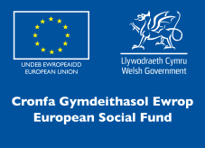
Only to be completed if you’re able to provide more than one session.
Working Wales
#changeyourstory
Section 2
Title of tutorial/ lesson/s - Partners to provide an easily understandable name of the course and length (e.g. one-off or 6-week etc) and confirm who is delivering it.
Online platform your session will be hosted on (beyond the ALW platform)
Able to provide content in Welsh? | Yes No
Brief description of online/tutorial session/s you can provide (please include any worksheets, previous reviews and important details).
For example, what it includes; who it is suitable for; what people will/ should get out of it; how long the commitment is. Max 250 words.
Category – how would you categorise your session/s from the list below: | Languages and communications Digital skills and technology Essential and employability skills Exercise, health and well-being Making and creating
Able to provide downloadable worksheet/ instruction manual? If yes, please provide links.
Overview of the business /relevant individuals who are running the course/s. The partner can provide a link to other courses here.
Max 250 words.

INTRODUCTION TO CREATIVE WRITING
A ten week course run by Cardiff University
ENQUIRE NOW

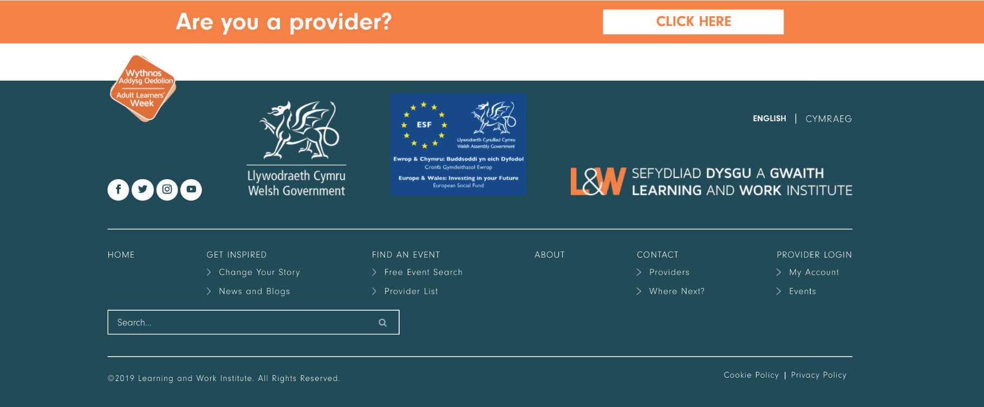
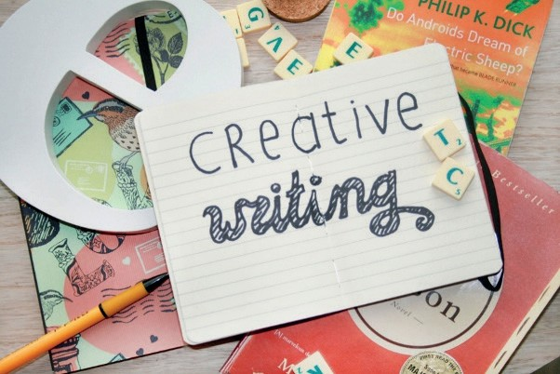

About the course
Are you intrigued by creative writing but not sure how to go about it? Does the blank page intimidate you?
This course offers an introduction to the main techniques of writing creatively and will enable you to develop your ideas in a friendly and supportive environment. Various forms of writing will be examined, including fiction and poetry, and work will be shared and discussed. This course is for anyone who has not yet started to write as well as those who are more experienced. You might wish to write for reasons of personal fulfilment or to produce work that could lead to possible publication.
This is a 10-credit course, so there will be two-hour online meetings once a week (20 contact hours in all) which will include discussions, exercises (optional), craft lectures and workshops. The aim is to ensure that the classes are enjoyable and stimulating for all.
To find out more about the course – watch our free introductory session here and visit [insert website] for more information on the full course.

About the course provider
Cardiff University was ranked 5th amongst UK universities in the 2014 Research Excellence Framework (REF) based on quality, and is a member of the Russell Group, a group of 24 leading UK research intensive universities.
The Creative Writing course is run by [INSERT CREDENTIALS OF THE COURSE LEADER]
In addition to this Creative Writing course, Cardiff University offers multiple courses ranging from maths and science-based learning to arts and humanities. For more information visit: https://www.cardiff.ac.uk/
Adult Learning: Arts & Crafts Cardiff Events:
Date:
E-mail:
Web address: www.cardiff.ac.uk Telephone: 029 1234 5678
Address: 123 Cardiff Road Cathays
Cardiff
Cardiff Univesity

SEWING FOR ALL
A five week course run by Usk Community Learning
ENQUIRE NOW

About the course
Have you ever wanted to make your own clothes? But don’t know your baste from your bitsy bag?
Learn to machine sew and follow patterns from the comfort of your own home.
Adult Learning: Arts & Crafts Cardiff Events:
Date:
E-mail:
Web address: www.monmouthshire.gov.uk/ communitylearning/usk-community- learning/
Telephone: 029 1234 5678
Address: 123 Cardiff Road Cathays
Cardiff
Usk Community Learning

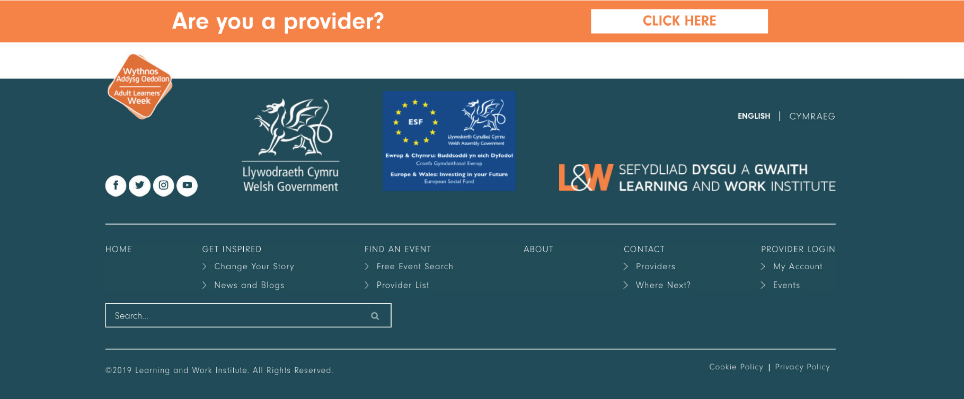
Suitable for all levels, this class will teach you brand new skills and allow your confidence to grow, whether you wish to make home furnishings or clothing items.
You will learn to follow patterns and achieve a professional finish. You will need a sewing machine and material to create your projects.
This is a 5-week course, so there will be one-hour online meetings once a week (five contact hours in all) which will include craft lectures and workshops.
To find out more about the course – watch our free introductory session here and visit [insert website] for

About the course provider
Elin Taylor has been crafting since she was young, thanks to her father an avid macramé maker who also taught a model workshop. Both of Elin’s grandmothers taught her to knit, crochet and embroider, which instilled a love of all things handmade. Elin has been making items of clothing for herself, family and friends for many years including fancy dress outfits, from Cleopatra to Tinkerbell, baby clothes and her very own wedding dress.
She has taught classes of various sizes and all ages, from complete beginners to experienced crafters who want to learn new techniques.
In addition to this Sewing For All course, Usk Community Learning offers multiple courses ranging from pottery, sugar craft and sewing. For more information visit: https://www.monmouthshire.gov.uk/communitylearning/usk-community-learning/

